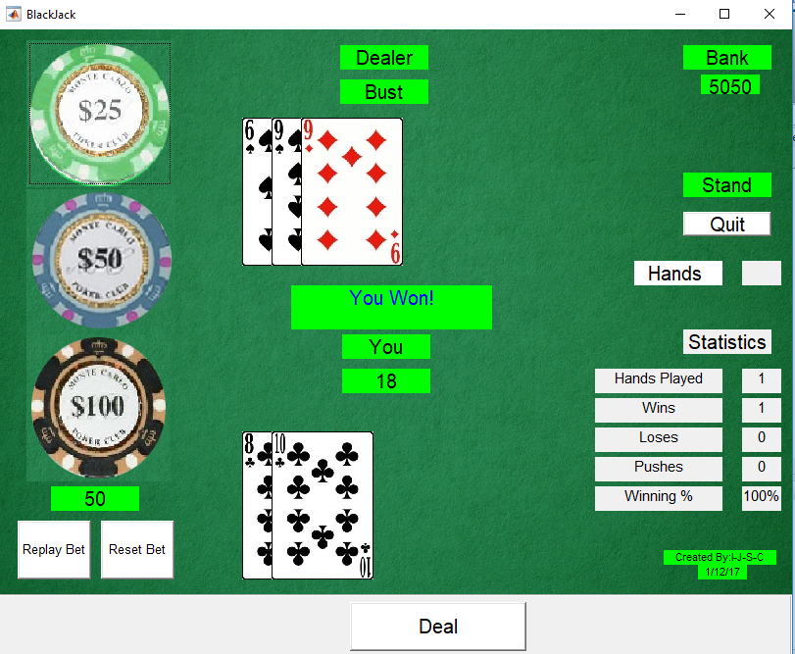

**Group Members:**

Scott Copley – 1701753

Ishmael Leon – 1703271

Kristoff Reid – 1504925

Jordane Kareem McCalla - 1707755

**Lecturer:**

Sir Ray Senior

**Date:**

November 27th 2017

**Module:**

Engineering Computing – ECE 1002

**Assignment** Black-Jack 21

Objectives

**Our project was to program a fully functional blackjack simulator using the MATLAB programming skills we learned in ECE 1002. This project truly unified all of the skills and concepts we learned this semester and required a lot more outside research of graphical user interfaces in MATLAB. In order to create the game we needed to combine logical and mathematical operators with GUI structure and image manipulation. The final project utilized all of this knowledge and more. We were very pleased with what we programmed and felt that it exemplified very well what is possible with the MATLAB programming language.**

Brief Introduction

**Blackjack is one of the most popular card games in the world with relatively simple rules. The player must try to beat the dealer by having a higher score without going over 21 points. In this project, are goal was to recreate a blackjack simulator. First we read about the casino rules for blackjack where the player is against the dealer. We also researched previous implementations of blackjack in MATLAB using Graphical User Interfaces by more experienced coders on YouTube, Math-Works & Stack Exchange.**

**Next, we planned out our project by thinking of what programs we would need to make and implement. After we had written all the programs, we did many tests and added more lines of code to make sure that everything was working properly.**

Background (Theory)

**Extended Blackjack Rules**

**As briefly mentioned, in order to win blackjack against a dealer, the player must have more points than the dealer without going over 21 points.**

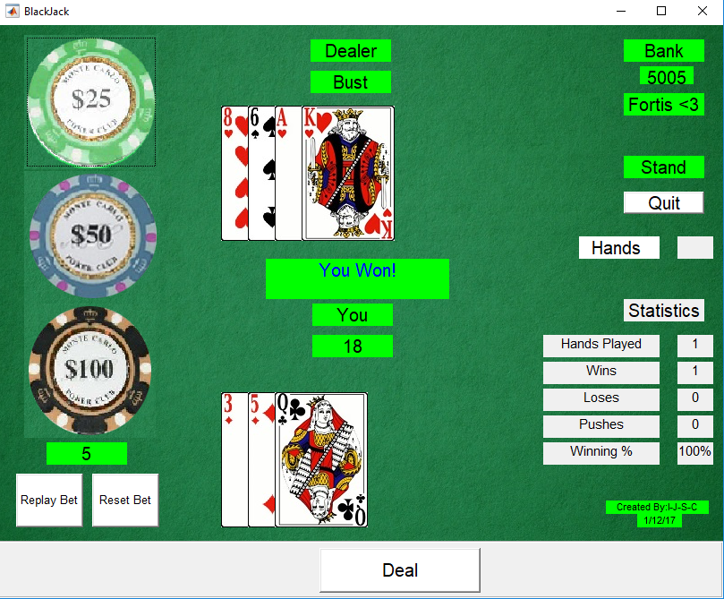

**The player and dealer are both dealt two cards but only one of the dealer's is faced up initially.**

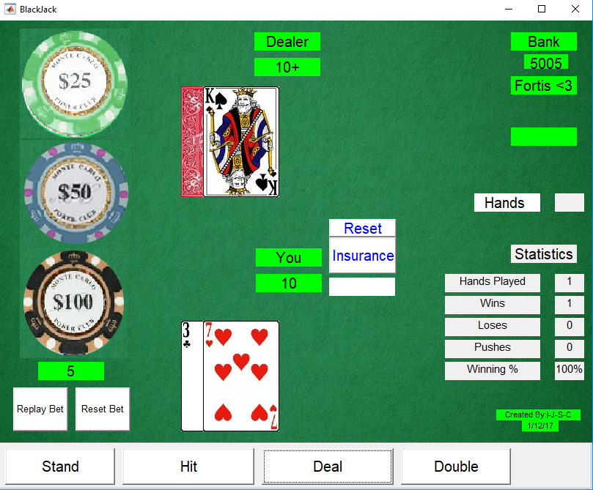

**Cards are worth their number value with jacks through kings also being ten points and aces can be eleven or one points depending on which works better.**

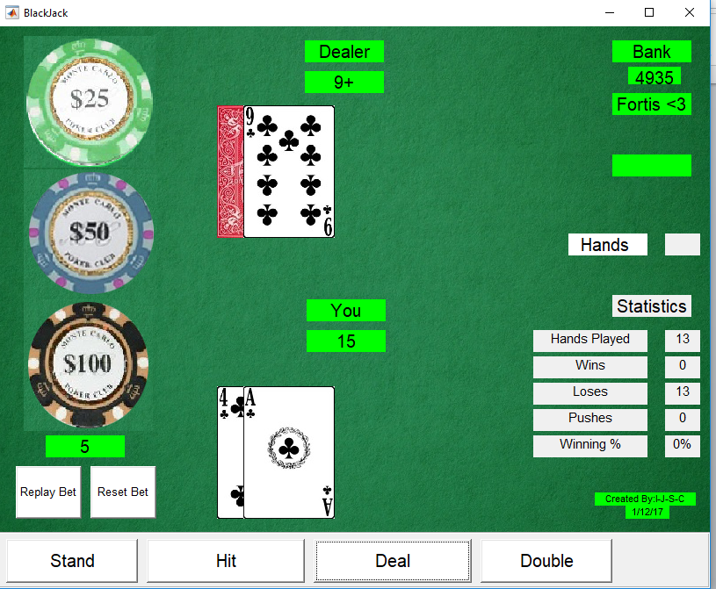

**First, it is the player's turn and the user can decide to hit (get another card) or stand (end their turn). If the player goes over 21 points, he/she busts and automatically loses.**

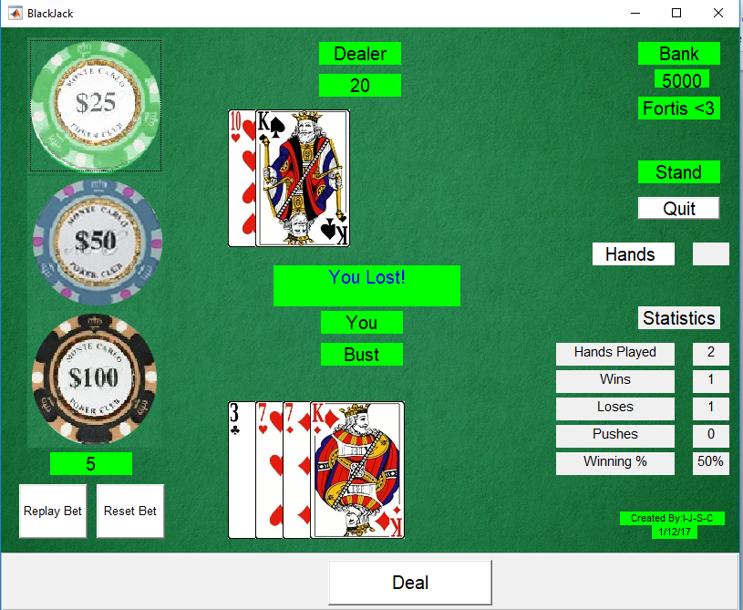

**Otherwise, it will then be the dealer's turn who will flip over his first card and must continue to hit until he either busts or has 17 points or greater. If neither the player nor dealer busts, then the winner is the person with more points and that person will win the bet.**

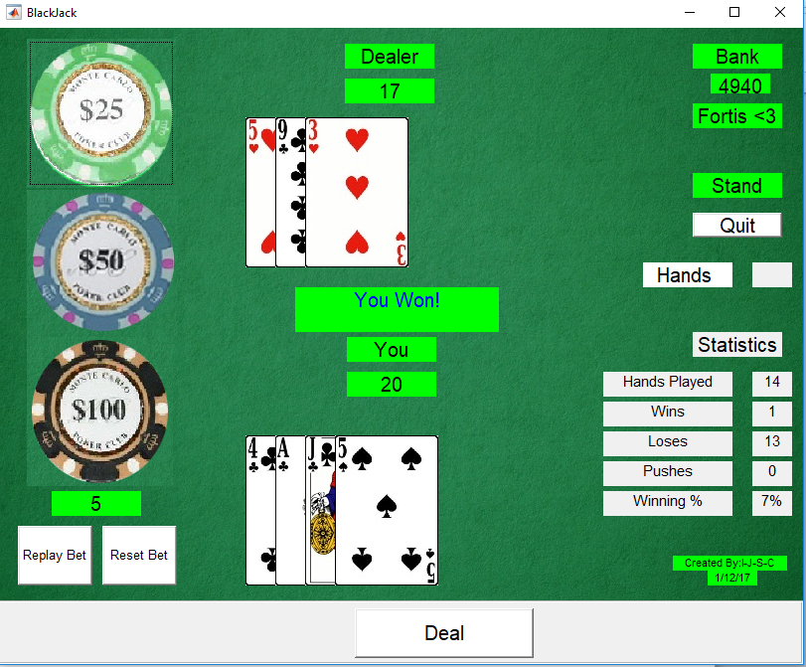

**It the player gets a blackjack, which is a ten-value card along with an ace, the player automatically wins 1.5 times his bet.**

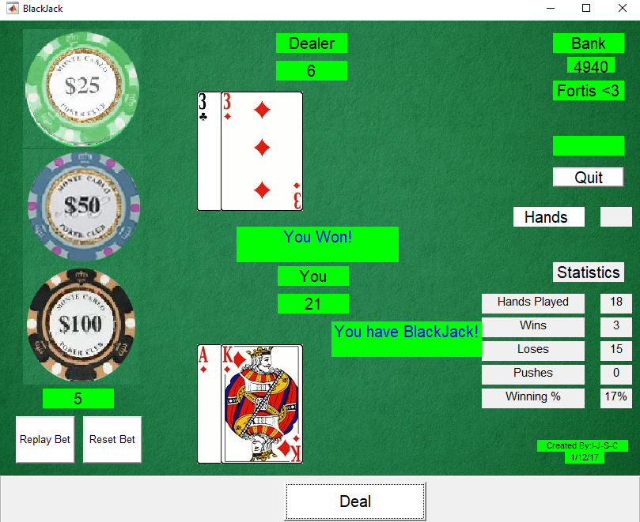

**If the player and dealer tie a round, then the bet is split and nobody loses or gains money. This is called a push.**

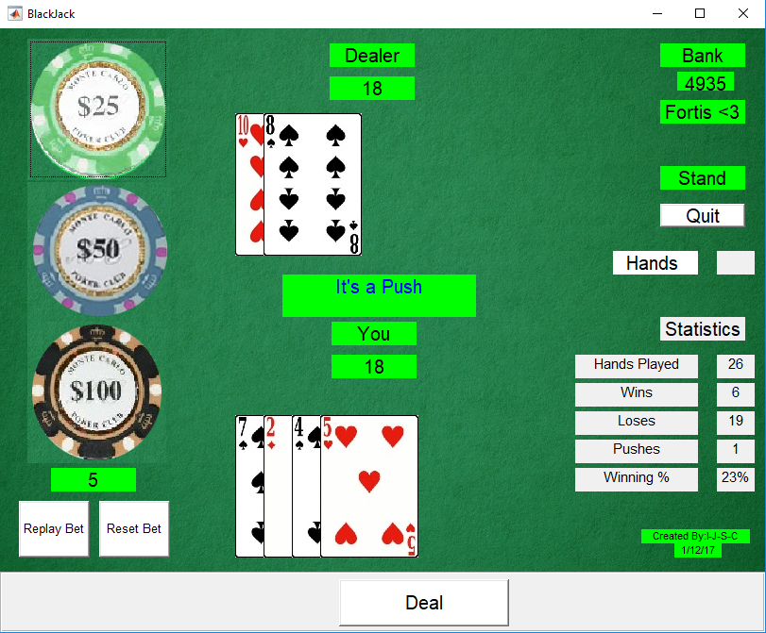

**Our project also has implementations of an insurance option.**

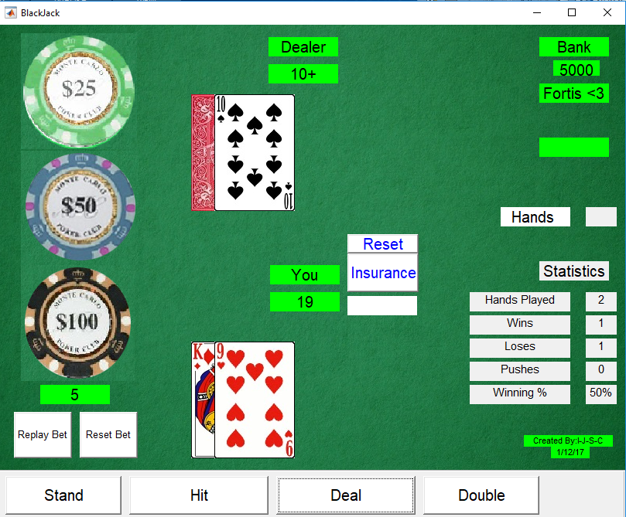

Programming Ideas

**After fully understanding the rules of blackjack, it immediately became clear that many if statements and while loops were going to be needed. If and else if statements will only execute if specific conditions are met, otherwise the program will skip that portion of the code. This is important because, for example, we would want the round to end right away if the player goes over 21 points because there would be no use in having the dealer go through his turn if that condition is met. While loops are indefinite loops that will continue to execute until certain conditions are changed. These were also important to the coding progress because, for example, when we wish for the user to play more than one hand of the game, a while loop would be necessary to start over the game.**

while ~QUITGAME

**…………. (body) …….**

**If wish to quitgame**

**QUITGAME = 1;**

**End**

**We also utilized while loops to separate the player’s turn from the dealer’s turn. When a certain condition is met (the player stands or busts), the while loop exists using a “break”,** **and switches to the dealer’s turn which is a while loop in itself**.

%Dealing of 2 cards for dealer & player

While ~firsthand

…. (code for the dealer) …

If wanting to end hand of dealer …

firsthand = 1;

end

%Player's Turn

while ~endhand

… (code for the player) ….

If wanting to end hand of player ..

endhand = 1;

end

… further code for the dealer to be ran …

Black-Jack Logic

**Before we could begin to create the visual aspect of our project it was necessary that we laid down the logical frameworks for the game itself. In blackjack, the player’s goal is to get a count, the sum of the value of the cards in their hand, which is closer to 21 than the dealer’s respective count, while also not being over 21. This is achieved by opting to either hit or stand on the player’s turn. Hitting entails adding another card to the player’s hand along with its subsequent count addition, while standing allows the dealer to make their moves and locks in the player’s current count.**

**After the player has finished making their moves, the dealer is allowed to make theirs. The dealer is subject to a strict set of rules when it comes to making their moves. They must always hit when their count is less than 17 and stand if their count is equal to or greater than 17.**

**Programming this logic into MATLAB was a challenge, but it was one we hoped to conquer. We used three separate row matrices, one entitled rank (randomized ranks [1-13]), the second being value (randomized values [1-10]) and the other called suit (randomized suits based on the number of decks [H,C,S,D….. n(SUIT)] . Anytime a card is needed to be chosen, we simply use a random index to obtain a random value and a random suit. We then utilized “imread”, an inbuilt function to read an image in MATLAB with these random characters from the deck of cards given by our lecturer Mr Senior.**

if (CARDS.Rank(n) <= 1*NumDecks*4)

**CARDS.Rank(n) = 1;**

**CARDS.Value(n) = 1;**

CARDS.CardCount(1)= CARDS.CardCount(1) + 1;

elseif (CARDS.Rank(n) <= 2*NumDecks*4)

**CARDS.Rank(n) = 2;**

**CARDS.Value(n) = 2;**

CARDS.CardCount(2) = CARDS.CardCount(2) + 1; % Ensures that the value occurence of cards

elseif (CARDS.Rank(n) <= 3*NumDecks*4) % Within a deck occurs a maximum of 4 times randomly

**CARDS.Rank(n) = 3;**

**CARDS.Value(n) = 3;**

CARDS.CardCount(3) = CARDS.CardCount(3) + 1; %Keeps track of the cards occurence in the 13 zeroed row matrix

elseif (CARDS.Rank(n) <= 4*NumDecks*4) %By adding one to the position

CARDS.Rank(n) = 4;

CARDS.Value(n) = 4;

CARDS.CardCount(4) = CARDS.CardCount(4) + 1;

elseif (CARDS.Rank(n) <= 5*NumDecks*4)

………etc (repetitive code) ….

for n = 1:(52*NumDecks)

%This sets the card's suit based on the original number's remainder

%when dividing by 4 -> 0 is clubs, 1 is hearts, 2 is spades, 3 is

%diamonds.

switch mod(CARDS.Rank(n), 4)

**case 0**

**CARDS.Suit(n) = 'C';**

**case 1**

**CARDS.Suit(n) = 'H';**  % Method in randomizing the card's suit by using a remainder calculation

**case 2**

**CARDS.Suit(n) = 'S';**

**case 3**

**CARDS.Suit(n) = 'D';**

…

**After assigning a variable to this random image, we used the ‘CDATA’ field on a general push-button to display the image on the board (GUI – BJBoardCreation).**

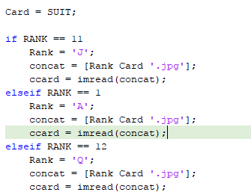

set(BJPLAYER.handle(BJPLAYER.handle_get +

1),'pos',[(BJPLAYER.XIncrement(1)+BJPLAYER.X1),

BJPLAYER.Y1, GENERAL.cwidth,

GENERAL.cheight],**'CData', Card_Spec,'visible','on');**

**We used global variables to distinguish hands, number of cards and the many other characteristics of a player or a dealer. For example, the global variable BJPLAYER has a sub-variable called BJPLAYER.Total, BJPLAYER.Blackjack and global variable BJDEALER has sub-variable BJDEALER.Bust. Using this method we were able to easily keep track of the sum of the value of cards for both the dealer and the player and even keep track of who has busted or obtained a blackjack.**

**Code checking for Aces**

%Check Player's Hand for ace/blackjack and compensate for it

if (CARDS.Value(CARDS.NextCard-2) == 1) %If the value of your first card is a 11, check it as an ace

if (BJPLAYER.Total + 10) > 21

BJPLAYER.Total = BJPLAYER.Total;

elseif (BJPLAYER.Total + 10) <= 21

**BJPLAYER.Total = BJPLAYER.Total + 10;**

**BJPLAYER.Ace** = 1; % Counts existence of an ace used as 11

end

elseif (CARDS.Value(CARDS.NextCard-1) == 1) %If the value of your second card is a 11

if (BJPLAYER.Total + 10) > 21

BJPLAYER.Total = BJPLAYER.Total;

elseif (BJPLAYER.Total + 10) <= 21

**BJPLAYER.Total = BJPLAYER.Total + 10;**

**BJPLAYER.Ace = 1**; % Counts existence of an ace used as 11

end

end

**Sample Code for Bust**

Check for dealer bust

if BJDEALER.Total > 21

set(handles.DealerTotalTxt,'string','Bust','visible','on');

BJDEALER.Bust = 1;

end

**This further enabled us to determine the result of the game at the end of a hand. These variables were created as matrices having row-column dimensions. This vector structure proved very susceptible to the manipulations we needed to perform on the hands. For example, BJPLAYER.Total would be created into a 1 by 2 matrix; First element being the total for the first hand in a split and the second element being the total for the second hand in a split.**

**Fragment of Code**

%If aces were split, the hand ends after two new cards are dealt

%Also, set ace field to 1 and update the totals

if (CARDS.Rank(BJPLAYER.Hand(1)) == 1) && (CARDS.Rank(BJPLAYER.Hand(2)) == 1)

endhand = 1;

BJPLAYER.Ace(1) = 1;

BJPLAYER.Ace(2) = 1;

BJPLAYER.Total(1) = 11;

BJPLAYER.Total(2) = 11;

else

BJPLAYER.Ace(1) = 0;

BJPLAYER.Ace(2) = 0;

**BJPLAYER.Total(1) = CARDS.Value(CARDS.NextCard-4);**

**BJPLAYER.Total(2) = CARDS.Value(CARDS.NextCard-3);**

end

**We also were able to set finite game sessions using a variable called HandsLeft. On each completion/ending of the while loop (the game), the variable (originally set in the setup menu), increments negatively by one. If the value of HandsLeft becomes 0, then the game ends with a prompt statement stating that the number of turns has ended.**

%Reduce # of hands to go by 1. If we're now at 0, set endhand to 1.

%If we were at 0 before, just keep going since there's no set # of

%hands

if BANKROLL.HandsLeft

BANKROLL.HandsLeft = BANKROLL.HandsLeft - 1;

set(handles.HandsLeftBox,'string',num2str(BANKROLL.HandsLeft));

if ~BANKROLL.HandsLeft

QUITGAME = 1;

msgbox('Game has ended, Hands are finished');

end

end

Black-Jack GUI

**After locking down the logic behind the game we set out to create a user interface which was both aesthetically pleasing and user friendly.**

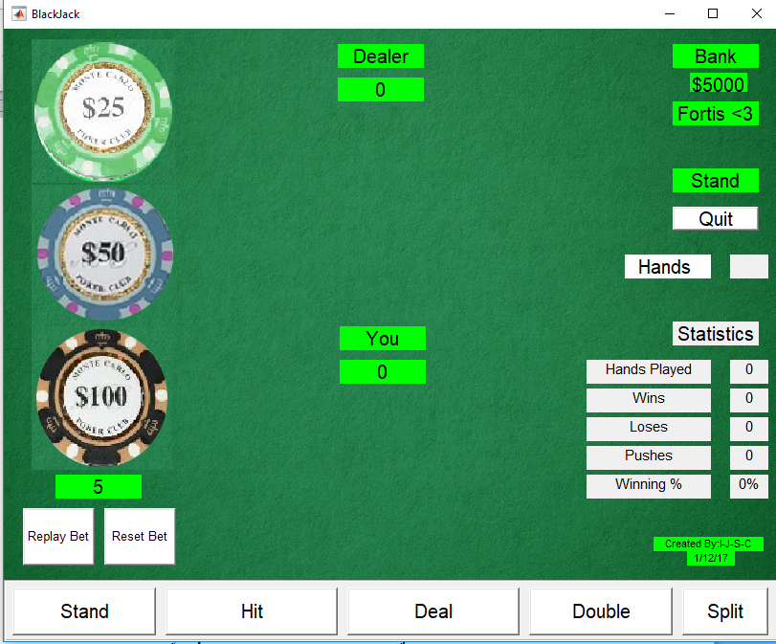

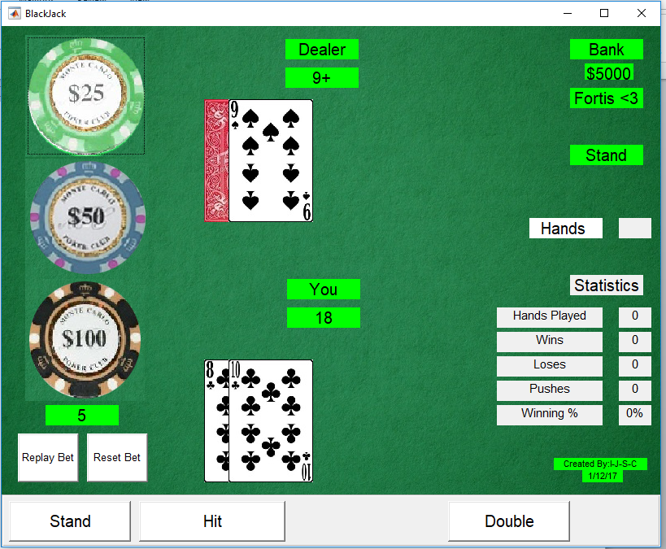

**Figures 1 shows our final GUI with all objects visible.**

**We felt that the final GUI we settled on accurately represented what an actual blackjack table looks like and conveyed to the user a crisp, clean experience.**

**The main feature of our GUI was the situational appearance of GUI elements, which allowed only the elements which the user could interact with to be visible at any given time. Using the ‘visible’ property of MATLAB handles we were able to turn elements on and off based on the current situation. Allowing the GUI to be altered in this fashion made our GUI appear clean and not overcrowded with information. Additionally, it ensured that the user could only interact with what we wanted them to be able to interact with.**

**Figure 1 is a screenshot of our graphical user interface with all elements set to visible. The interface consists of a main interface and a toolbar containing user strategic options. The main interface consists of buttons with images of chips overlaid onto them which call functions to aggregate a bet amount. In order to make the betting process more fluid we also included a button called “replay bet” which allows the user to replay the bet they made on the last hand rather than having to re-establish their bet each time. We also included a “reset bet” button which set the player’s bet back down to zero and allowed them to alter their bet if they had gone too high.**

**In order to plot the card images on the GUI we simply used the ‘CData’ field on pushbuttons after using the ‘IMREAD’ inbuilt function. Twelve push buttons are available for the player and seven push buttons for the dealer. We were aware that by allowing for only 6 card images for any given hand we ran the risk that a hand would contain more than 6 cards; however after playing thousands of hands with none reaching over 6 cards we were fairly confident that this would not be an issue. While it certainly was a possibility, the chances of it happening were very slim. We also included static text boxes which displayed the player and dealer counts for easy reference as well as a contextual game result box which displayed the game result based on these two counts.  
In the far right we displayed the player’s current bank amount on. In the bottom right hand corner we displayed a statistics grid which displayed relevant statistics to the game.**

Major Challenges/Bugs

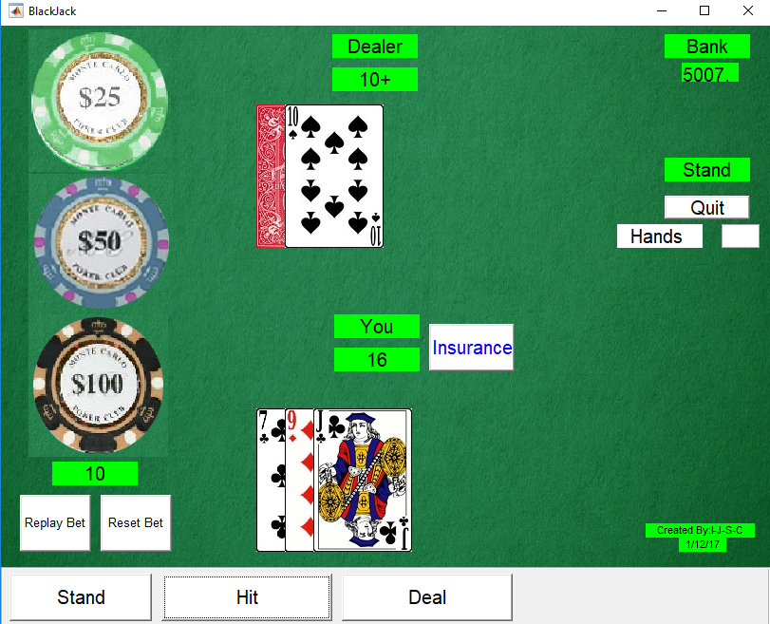

* Incorrect Total for Player

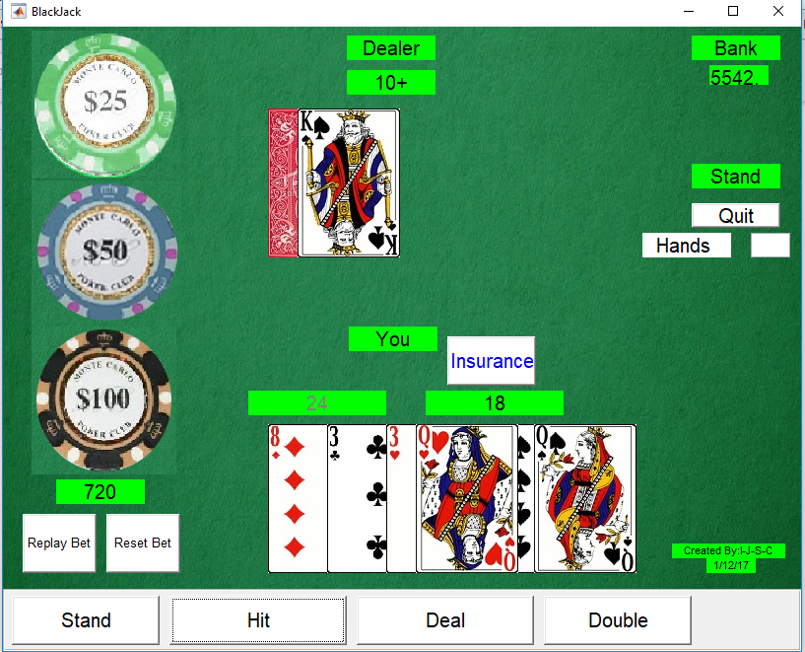

* Split function not clean enough to be seen

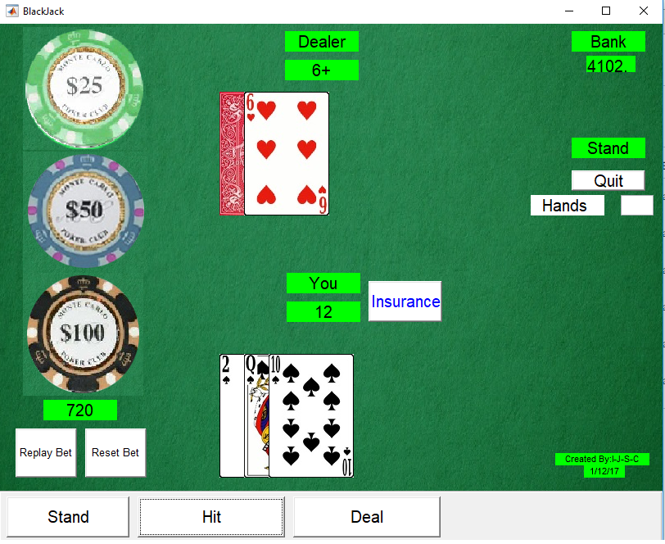

* 10 Value Cards not being counted

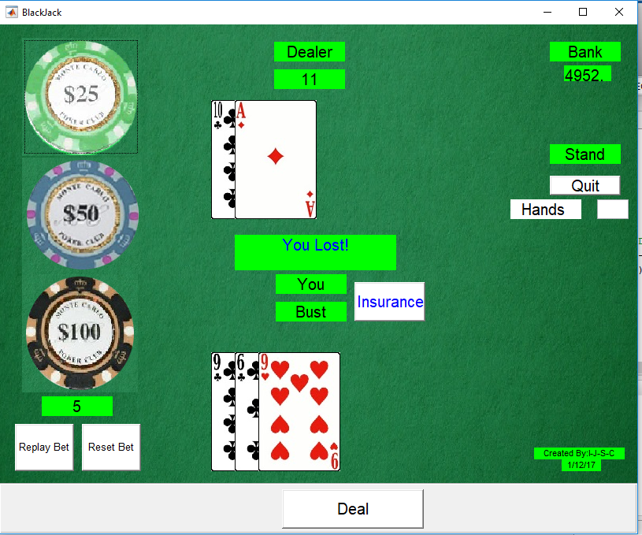

* Ace not interchanging values between 1 and 11 as it ought to

**One of the challenges we foresaw early on in our project was programming the game to read aces as their value should be based on the hand. The ace can take on a value of either 1 or 11, it is assigned whichever of these values gives the best count. While we initially thought this would be challenging it ended up being fairly straight forward. To alter the ace accordingly we wrote a function which searched the length of the hand vector for any 1s, the default ace value. It would then check the sum of the hand vector if the 1 was changed to an 11, if the alteration did not put the count over 21 the value of 11 was retained otherwise it reverted back to the original 1 value. We also needed to account for the reverse case where the ace is equal to 11, to do so we added another conditional to the function which searched the length of the hand vector for an 11 and changed it to a 1 if necessary to avoid the count exceeding 21. We executed this function every time the hand vectors were altered and found that it worked flawlessly.**

Definition of Functions

BJActionSelect :-

Function used to provide a communication pathway between the buttons on the GUI and the program

BJBoardCreation :-

Function used to create the board using the figure and uicontrol inbuilt functions

BJDealCard :-

Function used to distribute the cards to either the dealer or player on the board

BJDealerHits :-

Function to access the value of aces in a dealers hand and hence adjust the dealer’s total

BJPlayerHits :-

Function to access the value of aces in a players hand and hence adjust the player’s total

BJDetermineWinner :-

Determines the winner of a hand

BJStartValues :-

Creates the initial setup menu for the game

CardGet :-

Obtains a random card using the imread function

ShuffleNow :-

Shuffles the cards to be used in the game

HandsLeft :-

Keeps track of the hands left for the game

QuitGame :-

Controls the exiting of the game

Blackjack :-

Controls all peripheral functions and provides a while loop and if conditions for the various main functions of the game